# How to Triage and assign suggestions tickets for Community Contribution

1. Open <https://bpi.moravia.com/>. Go to the Community Contributions Module.  
   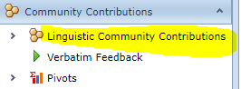
2. Click on Linguistic Community Contributions to see the Pull Requests Grid View.  
   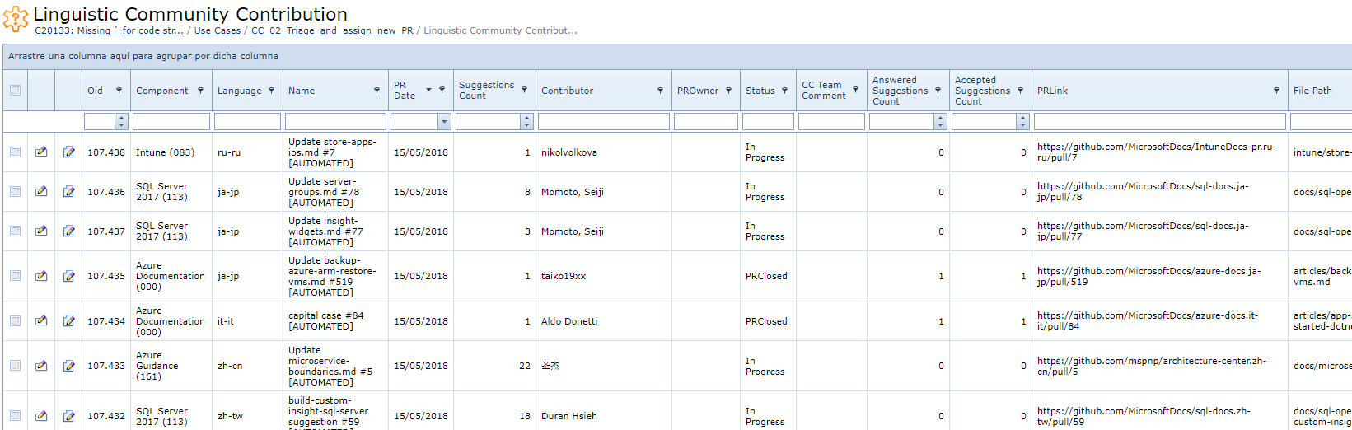  
   **Note:** You can add/remove/re-align Columns at your convenience. And select different filters options by just right clicking on the column bar.
3. Filter by Status= “Open”  
   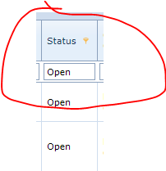
4. Click edit on the ticket you want to work on.  
   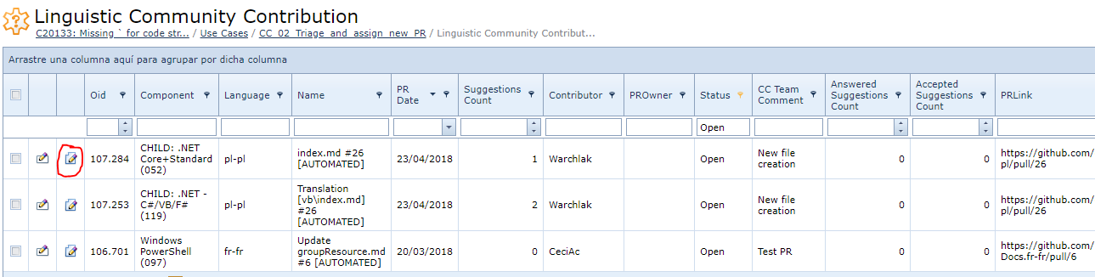
5. You will see the Pull Request BPI Ticket.  
   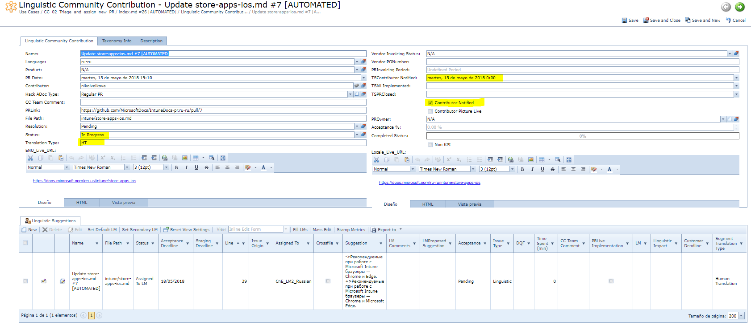
6. Change **Status** to “In Progress” and Save it.
7. Open the GitHub **PR link** in a different tab.   
   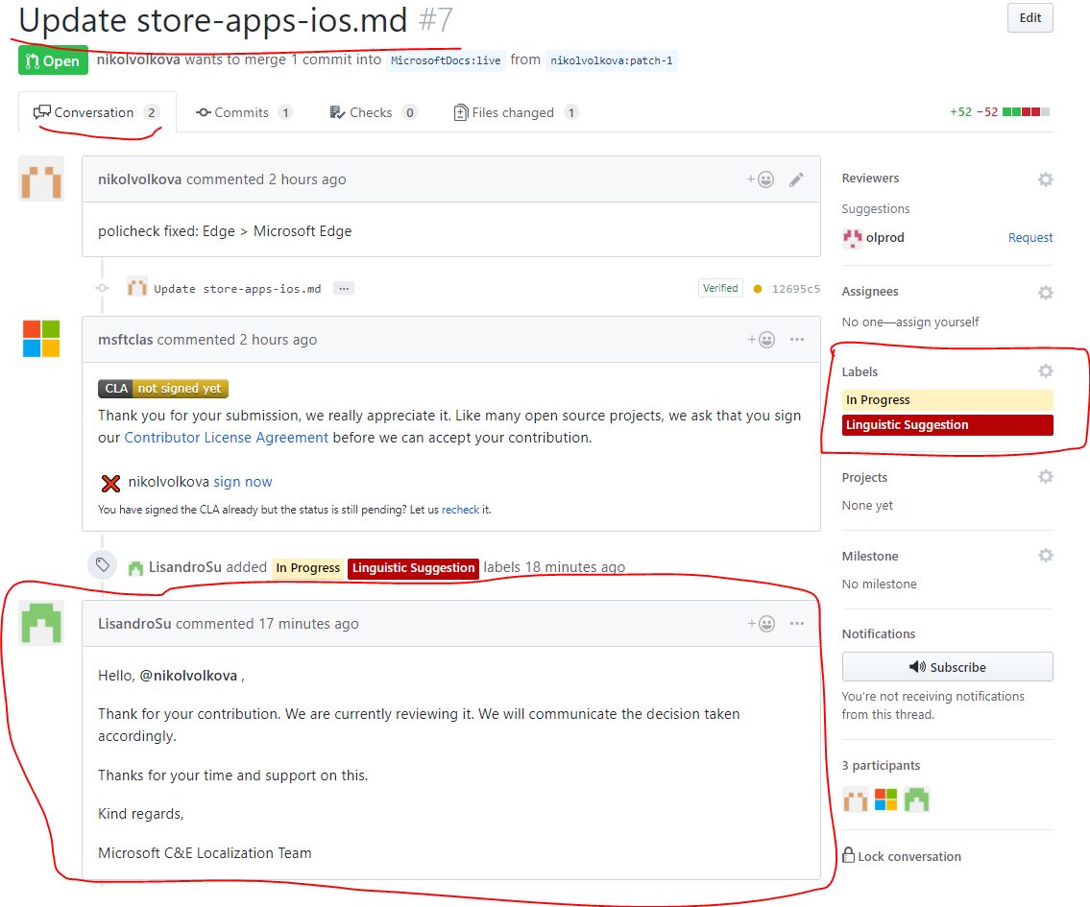
8. On the conversation Tab in GitHub. Add the comment to keep contributor in the loop. [Onenote](onenote://parana/Phases5/Microsoft_CnE/UA/Phases/Community_Contribution/01_Documentation/CC_OneNote/Community%20Contributions.one#Communication%20Scenarios&section-id={A431F119-E454-450F-BC89-782BD9B423E1}&page-id={BD78E62C-23D7-44FE-8823-40613C6412BB}&end)  
   Make sure to use native comment if Contributor first comment is in native language or blank.
9. Add the Labels:
   1. “In Progress “
   2. “Linguistic” If the Changes are linguistics (95% will be just this option)
   3. “Source Issue” If changes are about source changes
   4. “Technical” if changes are about formatting, etc.  
      **Note: A PR may have the 3 issues. (but very unlikely)**
10. Now, check the “Files changed” tab

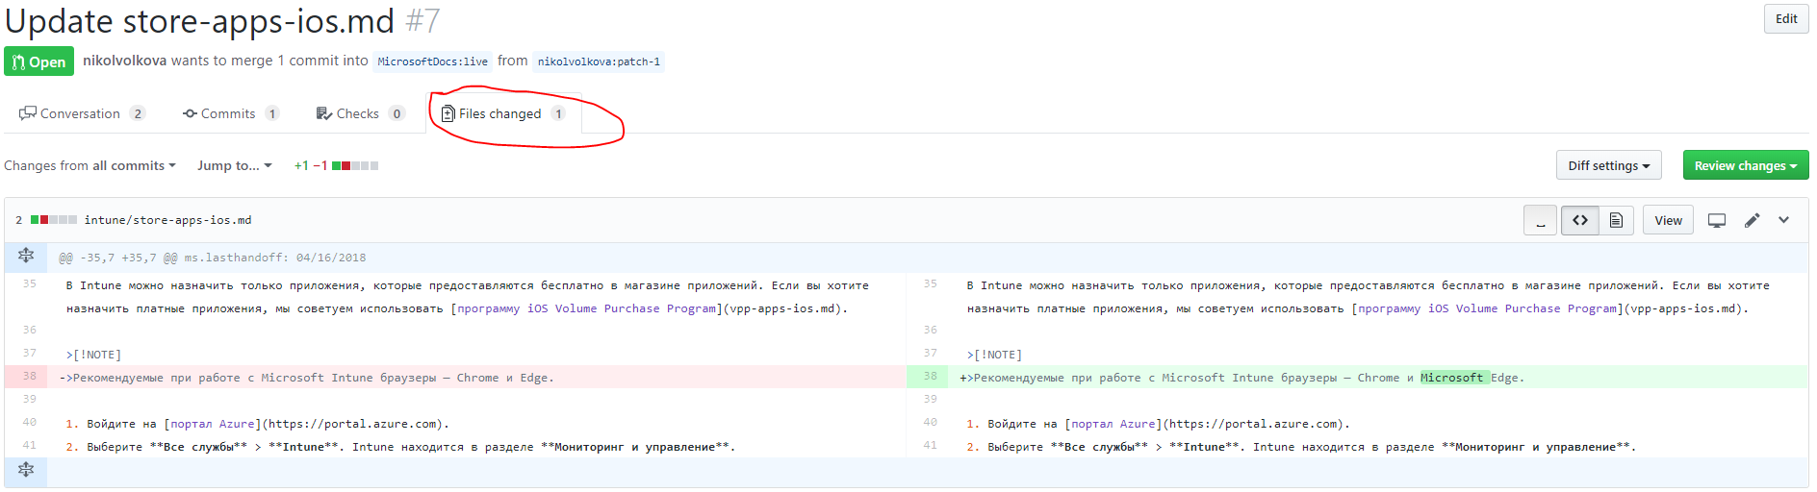

1. Add **?w=1** at the end of the URL so as to see all the real changes properly highlighted.  
   
2. Back in BPI check. Add the **TS Contributor notified** Date and check the **contributor notified** checkbox
3. Also, if all highlighted suggestions were properly imported in BPI. Probably not, and We will need to import the manually and modified the existing one since sometimes they are also wrongly imported.  
   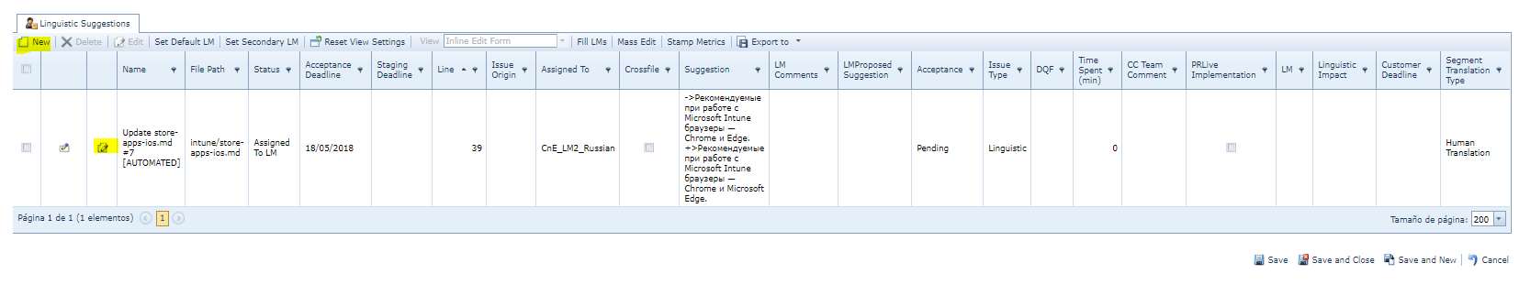  
   **Note: to modify click on the edit button and to create new Tickets click on “New”. Remember that we need to create one suggestion ticket per line change in GitHub.**
4. You will see the tickets like this.  
   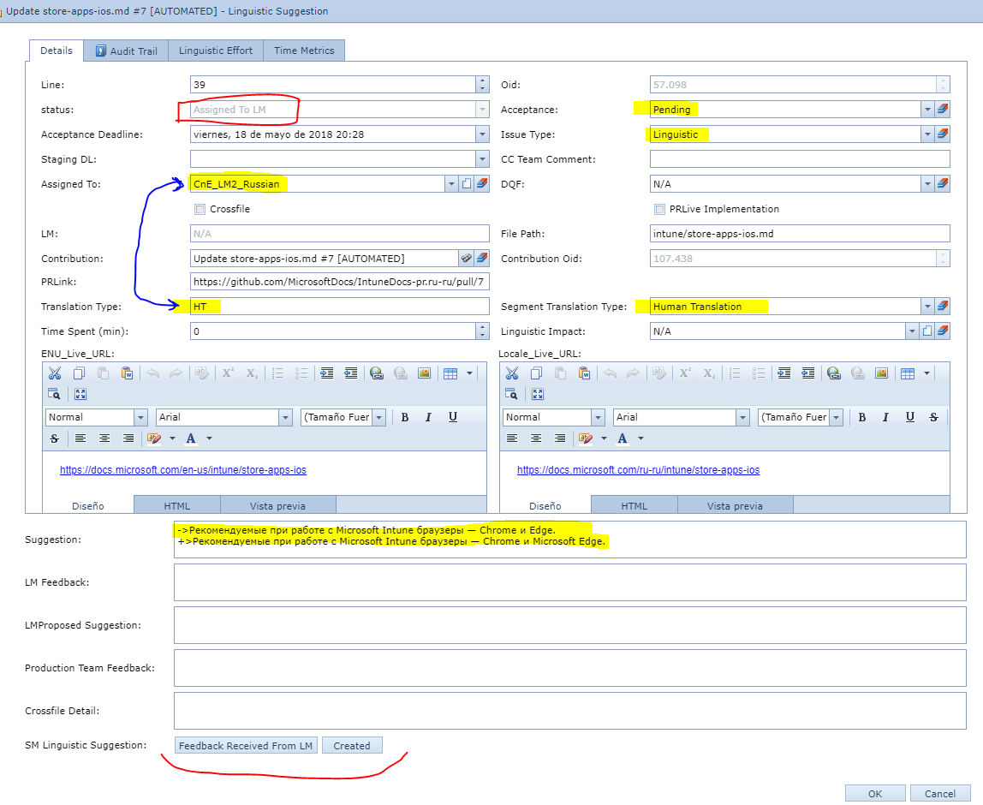
5. Change **Acceptance** to “Pending”
6. Change the **Issue type** either to “Linguistic Issue”, “technical” or “Source Issue”. Depending on the type of suggestions. Most likely will be linguistic.
7. Make Sure the Translation Type is completed. In case is not, check in the File changed tab on the file metadata section.  
   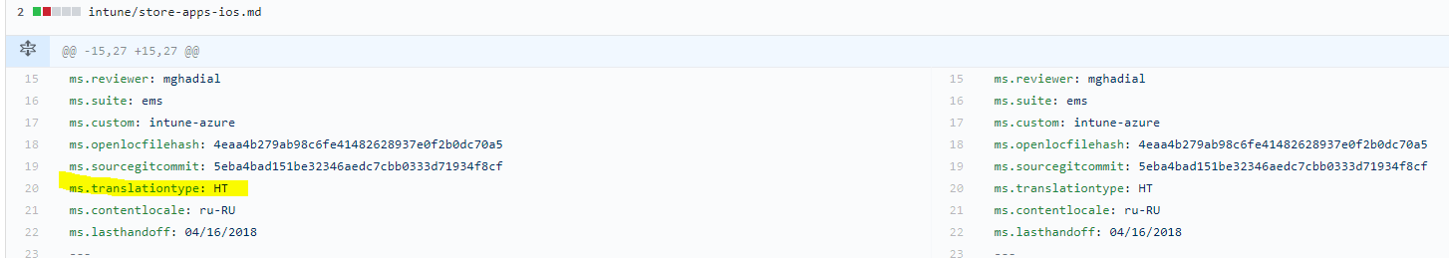  
   This also applies for the **Translation Type** at PR level.
8. Change or add the current translation (left red highlighted part) and the Contribution (right green highlighted part) into the **Suggestion** field
9. Change the **Assign to** field.  
   If **Translation Type** = “HT” assign to LMs. Check LM list [here](https://portal.moravia.com/prj/msce/LinguisticServices/wiki/SitePages/Language%20Moderators'%20Contacts%20and%20Product%20Ownership.aspx).  
   If **Translation Type** = “MT” assign to Linguistic vendor. Check list [here](onenote://parana/Phases5/Microsoft_CnE/UA/Phases/Community_Contribution/01_Documentation/CC_OneNote/Community%20Contributions.one#Vendor's%20Assigment%20Table&section-id={A431F119-E454-450F-BC89-782BD9B423E1}&page-id={0E1654DD-6712-4CCB-98AD-079AC244358A}&end).
10. Change **State Machine** at the bottom.  
    If **Translation Type** = “HT” and LM has been assigned. Click on “Assign to LM”  
    If **Translation Type** = “MT” and linguistic vendor been assigned. Click on “Assign to Linguistic Vendor”
11. Click **Save and close.**

## Common Scenarios for Source Escalations (Community Contributions)

This documentation will help you to detect Source Issues.

[Common Scenarios for Source Escalations](onenote://parana/Phases5/Microsoft_CnE/UA/Phases/Community_Contribution/01_Documentation/CC_OneNote/Community%20Contributions.one#Common%20Scenarios%20for%20Source%20Escalations%20&section-id={A431F119-E454-450F-BC89-782BD9B423E1}&page-id={E2E29E99-0164-431B-9D66-BE7E0F909582}&end)